
STUDENT INFORMATION:
First Name: _______________________________ Last Name: _________________________________
Address: _________________________________________________________________________________
City: ___________________________________ State: ___________________ Zip: __________________
Phone: ______________________ Age: ______________ (Must be 10 – 16 Years old)
Current School: __________________________________________________________________________
Instrument: ______________________________________________________________________________
Previous Lessons/Experience: ____________________________________________________________

PARENT/GUARDIAN INFORMATION:
First Name: _______________________________ Last Name: _________________________________
Address: _________________________________________________________________________________
City: ___________________________________ State: ___________________ Zip: __________________
Phone: ______________________ Email: __________________________________________________
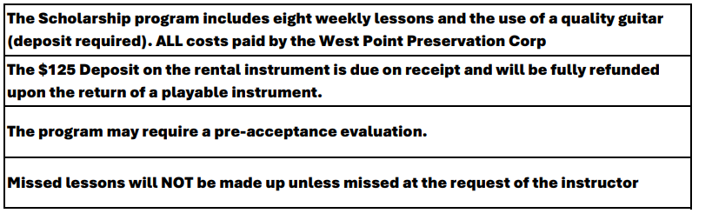
Student Signature: ______________________________________________________________
Parent/Guardian Signature: ______________________________________________________
Date: ___________________________________
Acceptance: __________________________________________ Date: ________________
RETURN APPLICATION TO: gary@brewgrass.com

